# **Abstract**

In modern software development, design patterns serve as standardized solutions to recurring architectural challenges. Predicting appropriate design patterns during the early stages of software development can significantly enhance code quality and maintainability. This Project explores the application of machine learning techniques to predict design patterns based on software requirements and context. By employing various algorithms such as decision trees, support vector machines, and neural networks, we train models on a dataset of software projects annotated with design patterns. Feature extraction techniques, including code metrics and structural attributes, are used to inform model training. The results demonstrate that machine learning models can accurately predict design patterns in software systems, providing developers with valuable insights during the design phase. This approach automates part of the software engineering process, improving efficiency and reducing human error in pattern selection.

# **Introduction**

Design patterns play a critical role in software engineering by offering well-established solutions to recurring design problems. They serve as blueprints that help developers create robust, scalable, and maintainable software systems. However, selecting the appropriate design pattern for a given problem can be a complex task, often requiring a deep understanding of both the problem domain and the design patterns themselves. This challenge is particularly pronounced for less experienced developers, who may struggle to recognize and apply these patterns effectively. In recent years, machine learning has emerged as a powerful tool for automating and enhancing various aspects of software development. Machine learning models can analyse large datasets, identify patterns, and make predictions, making them well-suited for tasks such as design pattern prediction. By leveraging machine learning techniques, we can develop systems that assist developers in identifying suitable design patterns based on the specific characteristics of their software projects. This Project proposes a machine learning-based approach to predict design patterns for software projects. Our system utilizes a dataset of annotated software projects to train machine learning models, including decision trees, support vector machines (SVMs), and neural networks. These models learn to recognize the structural and behavioural attributes of design patterns from the code and suggest appropriate patterns for new projects. Additionally, we incorporate natural language processing (NLP) techniques to analyse project documentation, further enhancing the accuracy of our predictions. The goal of this research is to provide a tool that aids developers in making informed design decisions, thereby improving the quality and efficiency of software development. By automating the identification of design patterns, we aim to reduce the cognitive load on developers, enabling them to focus on higher-level design and implementation tasks. Furthermore, our system can serve as an educational resource for less experienced developers, helping them to learn and apply design patterns more effectively

# **Literature Survey**

The importance of design patterns in software engineering has been widely acknowledged since their formal introduction by the "Gang of Four" (Gamma et al., 1994). These patterns provide reusable solutions to common design problems and enhance the quality, maintainability, and scalability of software. Over the years, various approaches have been proposed to facilitate the identification and application of design patterns in software systems.

**1. Manual and Semi-Automated Approaches**

Early efforts to assist developers in selecting appropriate design patterns focused on manual or semi-automated approaches. For instance, Buschmann et al. (1996) and Gamma et al. (1995) presented design pattern catalogues to help developers choose patterns based on problem descriptions. These methods, while useful, rely heavily on the developer's expertise and often lead to inconsistent results, particularly in large-scale projects or when developers are unfamiliar with certain patterns.

Semi-automated tools such as Design Pattern Wizard and MAP (Pattern Wizard) were introduced to guide developers by recommending patterns based on high-level design inputs. However, these tools often require substantial manual intervention, making them less scalable for complex software projects.

**2. Rule-Based Approaches**

To address the limitations of manual methods, several rule-based approaches were developed. In these approaches, predefined rules are used to map software design components to corresponding design patterns. For example, Zhang et al. (2006) proposed a rule-based pattern recognition system that identifies design patterns by analysing the structure of UML diagrams. Similarly, Dong et al. (2009) created a system that automatically detects design patterns in code by applying a set of heuristic rules.

While rule-based systems improved pattern identification, they struggled with flexibility and adaptability. Rules are often domain-specific and must be manually updated when dealing with new problem domains or design patterns. Additionally, these systems often suffer from low accuracy in complex software projects, where patterns might not strictly conform to predefined rules.

**3. Graph-Based and Structural Approaches**

Graph-based approaches have gained significant attention for design pattern detection. These methods represent software systems as graphs, where nodes represent classes or objects, and edges represent relationships such as inheritance or associations. The work of Antonoil et al. (2004) used graph matching techniques to identify design patterns based on graph isomorphism, allowing for the detection of structural similarities between software architectures and known design patterns. Moreover, patterns can be viewed as recurring subgraphs in software designs.

Another structural approach was proposed by Tantali’s et al. (2006), who used metrics and graph-based methods to detect design patterns in source code. They focused on the structural relationships between code elements, enabling the identification of patterns such as Singleton and Factory. These methods, while powerful, are computationally intensive and often struggle with identifying behavioural aspects of patterns.

**4. Machine Learning-Based Approaches**

Recent advancements in machine learning (ML) have paved the way for automated design pattern detection. Machine learning models are particularly suited for pattern recognition tasks due to their ability to learn from large datasets and generalize across different domains. ML-based approaches leverage features extracted from code or design representations and use these features to train models for pattern prediction.

One of the earliest works in this domain was presented by Hammad et al. (2013), who applied decision trees to predict design patterns based on structural metrics. More recent work by Malhotra et al. (2017) applied support vector machines (SVM) to detect design patterns by analysing class-level features, such as method calls and inheritance structures. Their results demonstrated that ML models could achieve high accuracy in pattern detection tasks, outperforming traditional rule-based approaches.

Deep learning techniques have also been explored for this task. Chen et al. (2019) applied convolutional neural networks (CNN) to extract features from code snippets and predict design patterns in object-oriented systems. Their results highlighted the potential of deep learning for automating the design pattern detection process, especially for large and complex software projects.

**5. Hybrid Approaches**

Some researchers have explored hybrid approaches that combine rule-based and machine learning methods. For example, a study by Kim et al. (2020) proposed a hybrid framework that integrates rule-based filtering with a machine learning classifier to improve design pattern detection accuracy. This method reduces the search space by applying rules first and then refines the prediction using ML models. Hybrid methods offer the flexibility of rule-based systems while leveraging the adaptability and learning capabilities of machine learning.

# **Existing System**

Current systems for design pattern identification in software engineering largely rely on manual processes and the expertise of experienced developers. Traditional approaches involve developers studying design pattern catalogues and matching their project requirements with the characteristics of various patterns. This process can be time-consuming and prone to errors, particularly for less experienced developers who may lack the necessary knowledge and intuition to select the most appropriate pattern. Additionally, existing tools that assist with design pattern identification often rely on static code analysis and predefined rules, which can be rigid and fail to adapt to the nuances of different projects. These tools typically analyse the structure of the codebase to detect known patterns, but they do not provide proactive recommendations or adapt to the specific context of a given project. As a result, the effectiveness of these tools is limited, and developers still face significant challenges in applying design patterns correctly and efficiently. This underscores the need for more intelligent, flexible, and adaptive systems to support design pattern identification and application in software development.

DRAW BACKS:

1. **Manual Effort and Expertise Required**: Traditional methods for identifying and applying design patterns rely heavily on the manual effort and expertise of experienced developers. This can be time-consuming and inefficient, especially for less experienced developers who may not be familiar with all the patterns.
2. **Static and Rigid Tools**: Existing tools that assist with design pattern identification often rely on static code analysis and predefined rules. These tools lack flexibility and adaptability, making them unable to handle the nuances and specific contexts of different software projects

# **Proposed System**

The proposed system for predicting design patterns using machine learning aims to overcome the limitations of existing methods by providing an intelligent, flexible, and adaptive solution. This system leverages advanced machine learning algorithms, including decision trees, support vector machines (SVMs), and neural networks, trained on a comprehensive dataset of software projects annotated with various design patterns. By extracting and analysing features from the code, such as class relationships, method signatures, and structural attributes, the system can recognize complex patterns and suggest appropriate design patterns for new projects. Additionally, natural language processing (NLP) techniques are employed to analyse project documentation, enhancing the accuracy of predictions by considering both code structure and textual descriptions. This integrated approach ensures that the system provides context-aware, personalized recommendations. The proposed system continuously learns from new data, improving its predictive capabilities over time, and offers proactive recommendations during the design phase, significantly reducing the cognitive load on developers and promoting best practices in software engineering.

**4. Advantages of the Proposed System**

The proposed system offers several advantages over traditional and existing machine learning-based approaches:

* **Higher Accuracy**: By incorporating both structural and behavioural features, the system improves the accuracy of design pattern predictions, particularly for dynamic patterns that are difficult to detect using structural features alone.
* **Reduced Manual Effort**: The system automates the design pattern selection process, reducing the reliance on the developer’s expertise and minimizing the risk of human error.
* **Scalability**: The use of graph-based representations and deep learning techniques enables the system to scale effectively to large, complex software architectures.
* **Generalization**: The machine learning models are trained on diverse datasets, enabling them to generalize across different types of software projects and domains.
* **Real-Time Assistance**: When integrated into an IDE, the system can provide real-time recommendations to developers, improving the overall software design workflow.

# **System Requirements**

**H/W System Configuration: -**

➢ Processor - Pentium –IV

➢ RAM - 4 GB (min)

➢ Hard Disk - 20 GB

➢ Key Board - Standard Windows Keyboard

➢ Mouse - Two or Three Button Mouse

➢ Monitor - SVGA

**SOFTWARE REQUIREMENTS: -**

* Operating system : Windows 7 Ultimate.
* Coding Language : Python.
* Front-End : Python.
* Back-End : Django-ORM
* Designing : Html, CSS, JavaScript.
* Data Base : MySQL (WAMP Server).

# **System Architecture**

The overall architecture of the proposed system consists of the following major components:

1. **Data Collection Module**
2. **Feature Extraction Module**
3. **Model Training Module**
4. **Pattern Prediction Engine**
5. **User Interface (IDE Integration)**

The system's architecture is illustrated as follows:

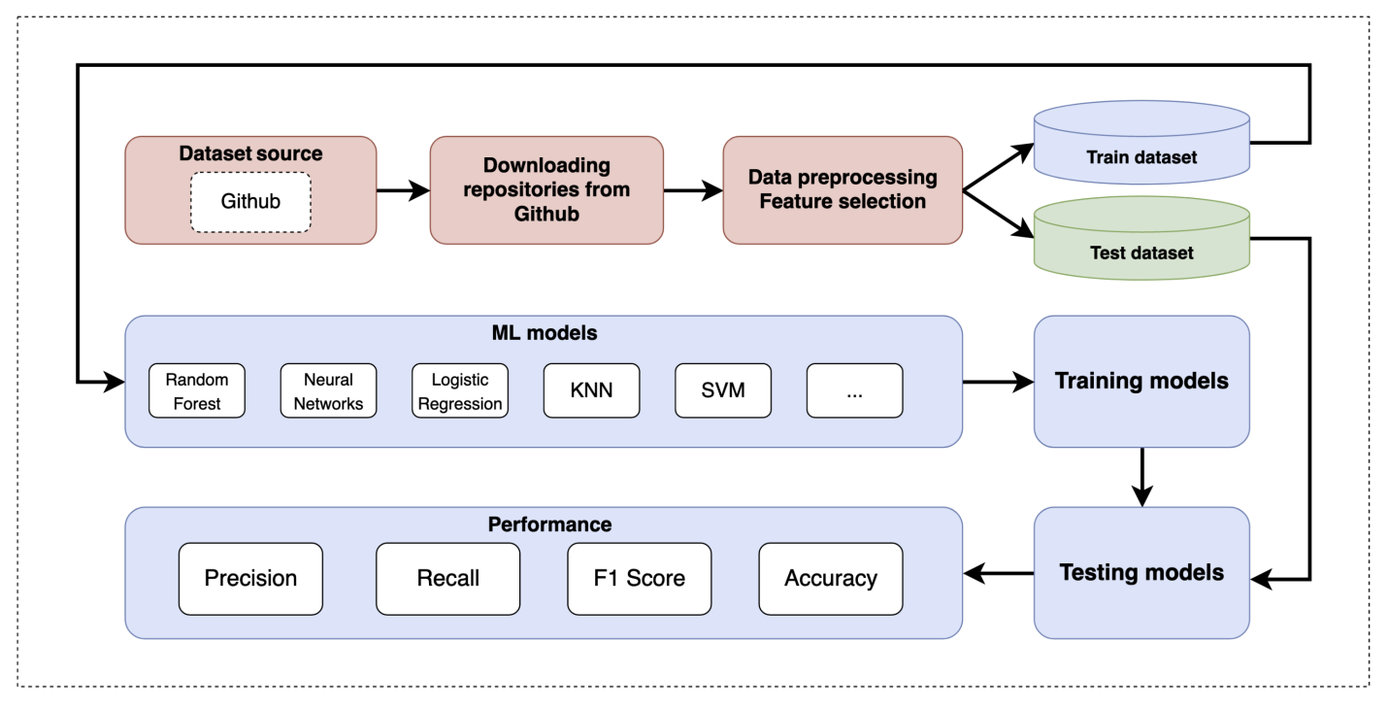

Here is an example of how the proposed system would work:

1. **Data Input**: The developer writes or uploads source code or design specifications (UML diagrams) into the IDE.
2. **Preprocessing and Feature Extraction**: The system preprocesses the input and extracts structural and behavioural features.
3. **Pattern Prediction**: The extracted features are sent to the trained model, which analyses them and predicts the design patterns.
4. **User Interaction**: The predictions are displayed within the IDE as recommendations, allowing the developer to view details or apply them to the software architecture.
5. **Feedback Loop**: The developer’s input (accepting or rejecting recommendations) is fed back into the system to fine-tune the models over time.

The system design of the proposed "Machine Learning Based Design Patterns Prediction" framework focuses on modularity, scalability, and integration with existing development environments. By automating the prediction and recommendation of design patterns, this system promises to assist developers in improving software architecture and design quality efficiently

# **UML Diagrams**

Here are some commonly used **UML diagrams** that can represent the **Machine Learning Based Design Patterns Prediction** system:

# **1. USE CASE DIAGRAM**

A **Use Case Diagram** shows the interaction between users (actors) and the system, illustrating the functional requirements. It highlights the key use cases, such as uploading source code, feature extraction, model training, and pattern prediction.

# **2. CLASS DIAGRAM:**

In software engineering, a class diagram in the Unified Modeling Language (UML) is a type of static structure diagram that describes the structure of a system by showing the system's classes, their attributes, operations (or methods), and the relationships among the classes. It explains which class contains information

# **3. SEQUENCE DIAGRAM:**

A sequence diagram in Unified Modeling Language (UML) is a kind of interaction diagram that shows how processes operate with one another and in what order. It is a construct of a Message Sequence Chart. Sequence diagrams are sometimes called event diagrams, event scenarios, and timing diagrams

# **4. COLLABRATION DIAGRAM:**

Activity diagrams are graphical representations of workflows of stepwise activities and actions with support for choice, iteration and concurrency. In the Unified Modeling Language, activity diagrams can be used to describe the business and operational step-by-step workflows of components in a system. An activity diagram shows the overall flow of control.

# **System Study**

**1. Current State Analysis**

The system study begins with an assessment of the current methods and technologies used for design pattern prediction:

* **Manual Methods**: Involves developers manually selecting and applying design patterns based on their expertise. This approach is error-prone and not scalable for large or complex projects.
* **Semi-Automated Tools**: Tools like Design Pattern Wizard provide recommendations based on user input but still require substantial manual intervention and lack flexibility.
* **Rule-Based Systems**: Systems such as DP-Miner and SPQR use heuristic rules to detect design patterns based on structural analysis. They are limited by their rigid rules and inability to handle dynamic or behavioural patterns.
* **Graph-Based Approaches**: Graph-based methods use structural graphs to identify patterns but are computationally intensive and mainly focus on static structures.
* **Early Machine Learning Models**: Preliminary models using decision trees and SVMs have demonstrated some success but are limited by feature selection and model accuracy.

**2. Requirements Analysis**

To design an effective machine learning-based design pattern prediction system, the following requirements must be addressed:

* **Functional Requirements**:
  + **Data Collection**: The system must gather and preprocess data from diverse sources, including code repositories and design diagrams.
  + **Feature Extraction**: Extract relevant structural and behavioural features from the software data.
  + **Model Training**: Train and validate machine learning models to predict design patterns.
  + **Pattern Prediction**: Predict design patterns based on new code or design specifications and provide recommendations.
  + **Integration**: The system should integrate with development environments (IDEs) to provide real-time predictions and recommendations.
* **Non-Functional Requirements**:
  + **Performance**: The system must handle large codebases efficiently and provide predictions in a timely manner.
  + **Scalability**: It should scale to accommodate complex and extensive software projects.
  + **Accuracy**: High prediction accuracy is essential to provide reliable design pattern recommendations.
  + **Usability**: The user interface must be intuitive and user-friendly, particularly when integrated into IDEs.
  + **Maintainability**: The system should be easy to update with new design patterns or evolving machine learning techniques.

**3. Feasibility Study**

**Technical Feasibility**:

* **Data Availability**: Data from code repositories (e.g., GitHub) and design documentation (UML diagrams) are accessible and can be used for training and evaluation.
* **Machine Learning Techniques**: Advances in machine learning and deep learning techniques are suitable for feature extraction and pattern prediction. Tools and libraries (e.g., TensorFlow, Porch) support the implementation of these techniques.
* **Integration**: IDE plugins or standalone applications can be developed using existing development tools and APIs, allowing integration with common IDEs like IntelliJ IDEA, Eclipse, and Visual Studio.

**Economic Feasibility**:

* **Cost of Implementation**: Costs include data acquisition, model development, and system integration. Using open-source tools and pre-existing machine learning libraries can help manage costs.
* **Return on Investment**: Automation of design pattern prediction can significantly reduce development time, improve code quality, and enhance maintainability, leading to a positive return on investment.

**Operational Feasibility**:

* **User Acceptance**: Developers are likely to appreciate tools that reduce manual effort and provide accurate recommendations. The system should be designed to seamlessly integrate into existing workflows.
* **Training and Support**: Adequate documentation and support must be provided to help users understand and effectively utilize the system.

**4. Potential Impact**

* **Improved Efficiency**: Automating the design pattern prediction process will streamline software development, reduce manual effort, and speed up the design phase.
* **Enhanced Code Quality**: Accurate design pattern recommendations can lead to better software architecture, resulting in higher-quality code that is more maintainable and scalable.
* **Reduced Human Error**: By minimizing reliance on manual pattern selection, the system reduces the risk of errors and inconsistencies in software design.
* **Knowledge Sharing**: The system can help disseminate design best practices and pattern knowledge, benefiting less experienced developers and promoting standardized design approaches.

**5. Risks and Mitigations**

* **Data Quality**: Inaccurate or incomplete data can impact model performance. Mitigation involves using diverse and high-quality datasets and implementing robust preprocessing techniques.
* **Model Accuracy**: The system may initially have lower accuracy due to limited training data or model limitations. Continuous improvement and regular updates to the models can address this issue.
* **Integration Challenges**: Integrating with various IDEs may present technical challenges. Developing a modular and flexible system architecture will facilitate smoother integration.

# System Testing

**1. Testing Objectives**

* **Functionality**: Verify that the system performs all intended functions, such as data collection, feature extraction, model training, pattern prediction, and integration with development environments.
* **Performance**: Assess the system's efficiency in handling large codebases, providing timely predictions, and scaling with increased data and complexity.
* **Accuracy**: Evaluate the precision of design pattern predictions and recommendations.
* **Usability**: Ensure that the user interface is intuitive and integrates seamlessly with IDEs or other development tools.
* **Stability**: Test the system’s reliability under various conditions and loads to identify and fix potential issues.

**2. Types of Testing**

**a. Functional Testing**

* **Unit Testing**: Test individual components of the system (e.g., data collection module, feature extraction, model training) to ensure that each component performs as expected. Use unit tests to check functions, methods, and classes.
* **Integration Testing**: Verify that different modules (data collection, feature extraction, model training, prediction engine) work together correctly. Ensure that data flows seamlessly between components and that integrated functionalities perform as intended.
* **System Testing**: Evaluate the complete system as a whole to ensure that all components interact correctly and that the system meets the specified requirements. Test the end-to-end workflow, from data input to pattern prediction and recommendation.
* **Acceptance Testing**: Conduct tests to confirm that the system meets the business requirements and user needs. This includes validating features against user stories and scenarios.

**b. Performance Testing**

* **Load Testing**: Assess how the system performs under expected and peak loads. Measure the system’s response time and throughput when processing varying volumes of data.
* **Stress Testing**: Evaluate the system's stability and performance under extreme conditions or loads that exceed typical usage scenarios. Identify potential failure points and system behaviour under stress.
* **Scalability Testing**: Test the system's ability to handle increasing amounts of data and complexity. Ensure that performance remains acceptable as the size of the codebase or number of design patterns increases.

**c. Accuracy Testing**

* **Model Accuracy**: Measure the accuracy of the machine learning models in predicting design patterns. Use metrics such as precision, recall, F1-score, and confusion matrices to evaluate model performance.
* **Cross-Validation**: Perform cross-validation to assess the generalizability of the models. Ensure that the models are not overfitting and can provide accurate predictions across different datasets.
* **Comparison Testing**: Compare the predictions of the system with known, manually identified design patterns to gauge accuracy and identify any discrepancies.

**d. Usability Testing**

* **User Interface Testing**: Evaluate the user interface for usability, intuitiveness, and ease of integration with IDEs. Test the interface with actual users (e.g., developers) to gather feedback on user experience.
* **Integration Testing with IDEs**: Verify that the system integrates properly with development environments and that real-time recommendations work as expected. Ensure that the plugin or tool does not interfere with the IDE’s functionality.

**e. Stability Testing**

* **Error Handling**: Test the system’s ability to handle errors and exceptions gracefully. Ensure that the system provides meaningful error messages and recovers from failures without crashing.
* **Recovery Testing**: Verify that the system can recover from unexpected disruptions, such as network failures or data corruption, without losing critical information or functionality.

**3. Testing Procedures**

**a. Test Plan Development**

* **Test Cases**: Develop detailed test cases for each type of testing. Each test case should include a description, test steps, expected results, and criteria for pass/fail.
* **Test Data**: Prepare test data that includes a variety of scenarios, including normal cases, edge cases, and stress cases. Use both synthetic and real-world datasets for comprehensive testing.

**b. Test Execution**

* **Testing Environment**: Set up a testing environment that mirrors the production environment as closely as possible. Ensure that all necessary tools, libraries, and dependencies are available.
* **Test Execution**: Execute the test cases according to the test plan. Record the results and compare them with the expected outcomes.
* **Defect Reporting**: Document any defects or issues discovered during testing. Provide detailed information about the issue, including steps to reproduce, expected vs. actual results, and severity.

**c. Test Results Analysis**

* **Results Review**: Analyse the test results to identify patterns, recurring issues, or areas for improvement. Review failed test cases and determine the root cause of any defects.
* **Model Evaluation**: Assess the performance of machine learning models based on accuracy metrics and compare results with baseline or benchmark models.
* **User Feedback**: Gather feedback from users who participated in usability testing to identify areas for improvement in the user interface or overall user experience.

**d. Test Reporting**

* **Test Summary Report**: Prepare a summary report that includes an overview of testing activities, test results, defect status, and recommendations for improvements.
* **Final Validation**: Conduct a final round of validation to ensure that all critical issues have been addressed and that the system meets all requirements before deployment.

**4. Continuous Testing**

* **Automated Testing**: Implement automated testing for repetitive and regression tests to streamline the testing process and ensure continuous integration.
* **Model Retraining**: Periodically retrain machine learning models with new data to maintain accuracy and adapt to evolving software patterns.
* **Ongoing Monitoring**: Monitor the system post-deployment to detect any issues that arise in the production environment and address them promptly.

# What is Python: -

Below are some facts about Python.

Python is currently the most widely used multi-purpose, high-level programming language.

Python allows programming in Object-Oriented and Procedural paradigms. Python programs generally are smaller than other programming languages like Java.

Programmers have to type relatively less and indentation requirement of the language, makes them readable all the time.

Python language is being used by almost all tech-giant companies like – Google, Amazon, Facebook, Instagram, Dropbox, Uber… etc.

The biggest strength of Python is huge collection of standard libraries which can be used for the following –

* + [Machine Learning](https://www.geeksforgeeks.org/machine-learning/)
  + GUI Applications (like Kiry, Skinter, Pit etc.)
  + Web frameworks like Django (used by YouTube, Instagram, Dropbox)
  + Image processing (like OpenCV, Pillow)
  + Web scraping (like Scrapy, Beautiful Soup, Selenium)
  + Test frameworks
  + Multimedia

### Advantages of Python: -

Let’s see how Python dominates over other languages.

#### 1. Extensive Libraries

Python downloads with an extensive library and it contain code for various purposes like regular expressions, documentation-generation, unit-testing, web browsers, threading, databases, CGI, email, image manipulation, and more. So, we don’t have to write the complete code for that manually.

#### 2. Extensible

As we have seen earlier, Python can be**extended to other languages**. You can write some of your code in languages like C++ or C. This comes in handy, especially in projects.

#### 3. Embeddable

Complimentary to extensibility, Python is embeddable as well. You can put your Python code in your source code of a different language, like C++. This lets us add **scripting capabilities**to our code in the other language.

#### 4. Improved Productivity

The language’s simplicity and extensive libraries render programmers**more productive** than languages like Java and C++ do. Also, the fact that you need to write less and get more things done.

#### 5. IOT Opportunities

Since Python forms the basis of new platforms like Raspberry Pi, it finds the future bright for the Internet of Things. This is a way to connect the language with the real world.

#### 6. Simple and Easy

When working with Java, you may have to create a class to print **‘Hello World’**. But in Python, just a print statement will do. It is also quite **easy to learn, understand,** and**code.** This is why when people pick up Python, they have a hard time adjusting to other more verbose languages like Java.

#### 7. Readable

Because it is not such a verbose language, reading Python is much like reading English. This is the reason why it is so easy to learn, understand, and code. It also does not need curly braces to define blocks, and **indentation is mandatory.** These further aids the readability of the code.

#### 8. Object-Oriented

This language supports both the **procedural and object-oriented**programming paradigms. While functions help us with code reusability, classes and objects let us model the real world. A class allows the **encapsulation of data** and functions into one.

#### 9. Free and Open-Source

Like we said earlier, Python is **freely available.** But not only can you[**download Python**](https://data-flair.training/blogs/install-python-windows/) for free, but you can also download its source code, make changes to it, and even distribute it. It downloads with an extensive collection of libraries to help you with your tasks.

#### 10. Portable

When you code your project in a language like C++, you may need to make some changes to it if you want to run it on another platform. But it isn’t the same with Python. Here, you need to**code only once**, and you can run it anywhere. This is called **Write Once Run Anywhere (WORA)**. However, you need to be careful enough not to include any system-dependent features.

#### 11. Interpreted

Lastly, we will say that it is an interpreted language. Since statements are executed one by one, **debugging is easier** than in compiled languages.

Any doubts till now in the advantages of Python? Mention in the comment section.

### Advantages of Python Over Other Languages

#### 1. Less Coding

Almost all of the tasks done in Python requires less coding when the same task is done in other languages. Python also has an awesome standard library support, so you don’t have to search for any third-party libraries to get your job done. This is the reason that many people suggest learning Python to beginners.

#### 2. Affordable

Python is free therefore individuals, small companies or big organizations can leverage the free available resources to build applications. Python is popular and widely used so it gives you better community support.

**The 2019 GitHub annual survey showed us that Python has overtaken Java in the most popular programming language category.**

#### 3. Python is for Everyone

Python code can run on any machine whether it is Linux, Mac or Windows. Programmers need to learn different languages for different jobs but with Python, you can professionally build web apps, perform data analysis and [**machine learning**](https://data-flair.training/blogs/machine-learning-tutorials-home/), automate things, do web scraping and also build games and powerful visualizations. It is an all-rounder programming language.

### Disadvantages of Python

So far, we’ve seen why Python is a great choice for your project. But if you choose it, you should be aware of its consequences as well. Let’s now see the downsides of choosing Python over another language.

#### 1. Speed Limitations

We have seen that Python code is executed line by line. But since [Python](https://www.python.org/) is interpreted, it often results in **slow execution**. This, however, isn’t a problem unless speed is a focal point for the project. In other words, unless high speed is a requirement, the benefits offered by Python are enough to distract us from its speed limitations.

#### 2. Weak in Mobile Computing and Browsers

While it serves as an excellent server-side language, Python is much rarely seen on the **client-side**. Besides that, it is rarely ever used to implement smartphone-based applications. One such application is called **Carbon Nelle**.

The reason it is not so famous despite the existence of Bryton is that it isn’t that secure.

#### 3. Design Restrictions

As you know, Python is **dynamically-typed**. This means that you don’t need to declare the type of variable while writing the code. It uses **duck-typing**. But wait, what’s that? Well, it just means that if it looks like a duck, it must be a duck. While this is easy on the programmers during coding, it can**raise run-time errors**.

#### 4. Underdeveloped Database Access Layers

Compared to more widely used technologies like **JDBC (Java Database Connectivity)** and **ODBC (Open Database Connectivity)**, Python’s database access layers are a bit underdeveloped. Consequently, it is less often applied in huge enterprises.

#### 5. Simple

No, we’re not kidding. Python’s simplicity can indeed be a problem. Take my example. I don’t do Java, I’m more of a Python person. To me, its syntax is so simple that the verbosity of Java code seems unnecessary.

This was all about the Advantages and Disadvantages of Python Programming Language.

**History of Python: -**

What do the alphabet and the programming language Python have in common? Right, both start with ABC. If we are talking about ABC in the Python context, it's clear that the programming language ABC is meant. ABC is a general-purpose programming language and programming environment, which had been developed in the Netherlands, Amsterdam, at the CWI (Centrum Wickenden &Informatica). The greatest achievement of ABC was to influence the design of Python. Python was conceptualized in the late 1980s. Guido van Rossum worked that time in a project at the CWI, called Amoeba, a distributed operating system. In an interview with Bill Venners1, Guido van Rossum said: "In the early 1980s, I worked as an implementer on a team building a language called ABC at Centrum door Wickenden end Informatica (CWI). I don't know how well people know ABC's influence on Python. I try to mention ABC's influence because I'm indebted to everything I learned during that project and to the people who worked on end on in the same Interview, Guido van Rossum continued: "I remembered all my experience and some of my frustration with ABC. I decided to try to design a simple scripting language that possessed some of ABC's better properties, but without its problems. So, I started typing. I created a simple virtual machine, a simple parser, and a simple runtime. I made my own version of the various ABC parts that I liked. I created a basic syntax, used indentation for statement grouping instead of curly braces or begin-end blocks, and developed a small number of powerful data types: a hash table (or dictionary, as we call it), a list, strings, and numbers."

**What is Machine Learning: -**

Before we take a look at the details of various machine learning methods, let's start by looking at what machine learning is, and what it isn't. Machine learning is often categorized as a subfield of artificial intelligence, but I find that categorization can often be misleading at first brush. The study of machine learning certainly arose from research in this context, but in the data science application of machine learning methods, it's more helpful to think of machine learning as a means of building models of data.

Fundamentally, machine learning involves building mathematical models to help understand data. "Learning" enters the fray when we give these models tunable parameters that can be adapted to observed data; in this way the program can be considered to be "learning" from the data. Once these models have been fit to previously seen data, they can be used to predict and understand aspects of newly observed data. I'll leave to the reader the more philosophical digression regarding the extent to which this type of mathematical, model-based "learning" is similar to the "learning" exhibited by the human brain. Understanding the problem setting in machine learning is essential to using these tools effectively, and so we will start with some broad categorizations of the types of approaches we'll discuss here.

**Categories Of Machine Leaning: -**

At the most fundamental level, machine learning can be categorized into two main types: supervised learning and unsupervised learning.

Supervised learning involves somehow modeling the relationship between measured features of data and some label associated with the data; once this model is determined, it can be used to apply labels to new, unknown data. This is further subdivided into classification tasks and regression tasks: in classification, the labels are discrete categories, while in regression, the labels are continuous quantities. We will see examples of both types of supervised learning in the following section.

Unsupervised learning involves modeling the features of a dataset without reference to any label, and is often described as "letting the dataset speak for itself." These models include tasks such as clustering and dimensionality reduction. Clustering algorithms identify distinct groups of data, while dimensionality reduction algorithms search for more succinct representations of the data. We will see examples of both types of unsupervised learning in the following section.

## Need for Machine Learning

Human beings, at this moment, are the most intelligent and advanced species on earth because they can think, evaluate and solve complex problems. On the other side, AI is still in its initial stage and haven’t surpassed human intelligence in many aspects. Then the question is that what is the need to make machine learn? The most suitable reason for doing this is, “to make decisions, based on data, with efficiency and scale”.

Lately, organizations are investing heavily in newer technologies like Artificial Intelligence, Machine Learning and Deep Learning to get the key information from data to perform several real-world tasks and solve problems. We can call it data-driven decisions taken by machines, particularly to automate the process. These data-driven decisions can be used, instead of using programing logic, in the problems that cannot be programmed inherently. The fact is that we can’t do without human intelligence, but other aspect is that we all need to solve real-world problems with efficiency at a huge scale. That is why the need for machine learning arises.

## Challenges in Machines Learning: -

While Machine Learning is rapidly evolving, making significant strides with cybersecurity and autonomous cars, this segment of AI as whole still has a long way to go. The reason behind is that ML has not been able to overcome number of challenges. The challenges that ML is facing currently are −

**Quality of data** − Having good-quality data for ML algorithms is one of the biggest challenges. Use of low-quality data leads to the problems related to data preprocessing and feature extraction.

**Time-Consuming task** − Another challenge faced by ML models is the consumption of time especially for data acquisition, feature extraction and retrieval.

**Lack of specialist persons** − As ML technology is still in its infancy stage, availability of expert resources is a tough job.

**No clear objective for formulating business problems** − Having no clear objective and well-defined goal for business problems is another key challenge for ML because this technology is not that mature yet.

**Issue of overfitting & underfitting** − If the model is overfitting or underfitting, it cannot be represented well for the problem.

**Curse of dimensionality** − Another challenge ML model faces is too many features of data points. This can be a real hindrance.

**Difficulty in deployment** − Complexity of the ML model makes it quite difficult to be deployed in real life.

## Applications of Machines Learning: -

Machine Learning is the most rapidly growing technology and according to researchers we are in the golden year of AI and ML. It is used to solve many real-world complex problems which cannot be solved with traditional approach. Following are some real-world applications of ML −

* Emotion analysis
* Sentiment analysis
* Error detection and prevention
* Weather forecasting and prediction
* Stock market analysis and forecasting
* Speech synthesis
* Speech recognition
* Customer segmentation
* Object recognition
* Fraud detection
* Fraud prevention
* Recommendation of products to customer in online shopping

# How to Start Learning Machine Learning?

Arthur Samuel coined the term **“Machine Learning”** in 1959 and defined it as a **“Field of study that gives computers the capability to learn without being explicitly programmed”.**

And that was the beginning of Machine Learning! In modern times, Machine Learning is one of the most popular (if not the most!) career choices. According to [Indeed](http://blog.indeed.com/2019/03/14/best-jobs-2019/), Machine Learning Engineer Is the Best Job of 2019 with a 344% growth and an average base salary of **$146,085** per year.

But there is still a lot of doubt about what exactly is Machine Learning and how to start learning it? So, this article deals with the Basics of Machine Learning and also the path you can follow to eventually become a full-fledged Machine Learning Engineer. Now let’s get started!!!

### How to start learning ML?

This is a rough roadmap you can follow on your way to becoming an insanely talented Machine Learning Engineer. Of course, you can always modify the steps according to your needs to reach your desired end-goal!

### Step 1 – Understand the Prerequisites

In case you are a genius, you could start ML directly but normally, there are some prerequisites that you need to know which include Linear Algebra, Multivariate Calculus, Statistics, and Python. And if you don’t know these, never fear! You don’t need a Ph.D. degree in these topics to get started but you do need a basic understanding.

#### (a) Learn Linear Algebra and Multivariate Calculus

Both Linear Algebra and Multivariate Calculus are important in Machine Learning. However, the extent to which you need them depends on your role as a data scientist. If you are more focused on application heavy machine learning, then you will not be that heavily focused on math’s as there are many common libraries available. But if you want to focus on R&D in Machine Learning, then mastery of Linear Algebra and Multivariate Calculus is very important as you will have to implement many ML algorithms from scratch.

#### (b) Learn Statistics

Data plays a huge role in Machine Learning. In fact, around 80% of your time as an ML expert will be spent collecting and cleaning data. And statistics is a field that handles the collection, analysis, and presentation of data. So, it is no surprise that you need to learn it!!!  
Some of the key concepts in statistics that are important are Statistical Significance, Probability Distributions, Hypothesis Testing, Regression, etc. Also, Bayesian Thinking is also a very important part of ML which deals with various concepts like Conditional Probability, Priors, and Posteriors, Maximum Likelihood, etc.

#### (c) Learn Python

Some people prefer to skip Linear Algebra, Multivariate Calculus and Statistics and learn them as they go along with trial and error. But the one thing that you absolutely cannot skip is [Python](https://www.geeksforgeeks.org/python-programming-language/)! While there are other languages you can use for Machine Learning like R, Scala, etc. Python is currently the most popular language for ML. In fact, there are many Python libraries that are specifically useful for Artificial Intelligence and Machine Learning such as [Kera’s](https://keras.io/), [TensorFlow](https://www.tensorflow.org/), [Scikit-learn](https://scikit-learn.org/stable/), etc.

So, if you want to learn ML, it’s best if you learn Python! You can do that using various online resources and courses such as [**Fork Python**](https://practice.geeksforgeeks.org/courses/fork-python) available Free on So,

### Step 2 – Learn Various ML Concepts

Now that you are done with the prerequisites, you can move on to actually learning ML (Which is the fun part!!!) It’s best to start with the basics and then move on to the more complicated stuff. Some of the basic concepts in ML are:

#### (a) Terminologies of Machine Learning

* **Model –**A model is a specific representation learned from data by applying some machine learning algorithm. A model is also called a hypothesis.
* **Feature –**A feature is an individual measurable property of the data. A set of numeric features can be conveniently described by a feature vector. Feature vectors are fed as input to the model. For example, in order to predict a fruit, there may be features like colour, smell, taste, etc.
* **Target (Label) –**A target variable or label is the value to be predicted by our model. For the fruit example discussed in the feature section, the label with each set of input would be the name of the fruit like apple, orange, banana, etc.
* **Training –**The idea is to give a set of inputs(features) and it’s expected outputs(labels), so after training, we will have a model (hypothesis) that will then map new data to one of the categories trained on.
* **Prediction –**Once our model is ready, it can be fed a set of inputs to which it will provide a predicted output(label).

#### (b) Types of Machine Learning

* **Supervised Learning –**This involves learning from a training dataset with labelled data using classification and regression models. This learning process continues until the required level of performance is achieved.
* **Unsupervised Learning –**This involves using unlabelled data and then finding the underlying structure in the data in order to learn more and more about the data itself using factor and cluster analysis models.
* **Semi-supervised Learning –**This involves using unlabelled data like Unsupervised Learning with a small amount of labelled data. Using labelled data vastly increases the learning accuracy and is also more cost-effective than Supervised Learning.
* **Reinforcement Learning –**This involves learning optimal actions through trial and error. So, the next action is decided by learning behaviours that are based on the current state and that will maximize the reward in the future.

### Advantages of Machine learning: -

#### 1. Easily identifies trends and patterns -

Machine Learning can review large volumes of data and discover specific trends and patterns that would not be apparent to humans. For instance, for an e-commerce website like Amazon, it serves to understand the browsing behaviours and purchase histories of its users to help cater to the right products, deals, and reminders relevant to them. It uses the results to reveal relevant advertisements to them.

#### 2. No human intervention needed (automation)

With ML, you don’t need to babysit your project every step of the way. Since it means giving machines the ability to learn, it lets them make predictions and also improve the algorithms on their own. A common example of this is anti-virus software’s; they learn to filter new threats as they are recognized. ML is also good at recognizing spam.

#### 3. Continuous Improvement

As [**ML algorithms**](https://data-flair.training/blogs/machine-learning-algorithms/) gain experience, they keep improving in accuracy and efficiency. This lets them make better decisions. Say you need to make a weather forecast model. As the amount of data you have keeps growing, your algorithms learn to make more accurate predictions faster.

#### 4. Handling multi-dimensional and multi-variety data

Machine Learning algorithms are good at handling data that are multi-dimensional and multi-variety, and they can do this in dynamic or uncertain environments.

#### 5. Wide Applications

You could be an e-tailer or a healthcare provider and make ML work for you. Where it does apply, it holds the capability to help deliver a much more personal experience to customers while also targeting the right customers.

### Disadvantages of Machine Learning: -

#### 1. Data Acquisition

Machine Learning requires massive data sets to train on, and these should be inclusive/unbiased, and of good quality. There can also be times where they must wait for new data to be generated.

#### 2. Time and Resources

ML needs enough time to let the algorithms learn and develop enough to fulfill their purpose with a considerable amount of accuracy and relevancy. It also needs massive resources to function. This can mean additional requirements of computer power for you.

#### 3. Interpretation of Results

Another major challenge is the ability to accurately interpret results generated by the algorithms. You must also carefully choose the algorithms for your purpose.

#### 4. High error-susceptibility

[**Machine Learning**](https://en.wikipedia.org/wiki/Machine_learning) is autonomous but highly susceptible to errors. Suppose you train an algorithm with data sets small enough to not be inclusive. You end up with biased predictions coming from a biased training set. This leads to irrelevant advertisements being displayed to customers. In the case of ML, such blunders can set off a chain of errors that can go undetected for long periods of time. And when they do get noticed, it takes quite some time to recognize the source of the issue, and even longer to correct it.

**Python Development Steps: -**

Guido Van Rossum published the first version of Python code (version 0.9.0) at Altisource’s in February 1991. This release included already exception handling, functions, and the core data types of lists, duct, str and others. It was also object oriented and had a module system.  
Python version 1.0 was released in January 1994. The major new features included in this release were the functional programming tools lambda, map, filter and reduce, which Guido Van Rossum never liked. Six and a half years later in October 2000, Python 2.0 was introduced. This release included list comprehensions, a full garbage collector and it was supporting Unicode. Python flourished for another 8 years in the versions 2.x before the next major release as Python 3.0 (also known as "Python 3000" and "Py3K") was released. Python 3 is not backwards compatible with Python 2.x. The emphasis in Python 3 had been on the removal of duplicate programming constructs and modules, thus fulfilling or coming close to fulfilling the 13th law of the Zen of Python: "There should be one -- and preferably only one -- obvious way to do Unicode. Python changes in Python 7.3:

* Print is now a function
* Views and iterators instead of lists
* The rules for ordering comparisons have been simplified. E.g. a heterogeneous list cannot be sorted, because all the elements of a list must be comparable to each other.
* There is only one integer type left, i.e. int. long is int as well.
* The division of two integers returns a float instead of an integer. "//" can be used to have the "old" behaviour.
* Text Vs. Data Instead of Unicode Vs. 8-bit

**Purpose: -**

We demonstrated that our approach enables successful segmentation of intra-retinal layers—even with low-quality images containing speckle noise, low contrast, and different intensity ranges throughout—with the assistance of the ANIS feature.

**Python**

Python is an interpreted high-level programming language for general-purpose programming. Created by Guido van Rossum and first released in 1991, Python has a design philosophy that emphasizes code readability, notably using significant whitespace.

Python features a dynamic type system and automatic memory management. It supports multiple programming paradigms, including object-oriented, imperative, functional and procedural, and has a large and comprehensive standard library.

* Python is Interpreted − Python is processed at runtime by the interpreter. You do not need to compile your program before executing it. This is similar to PERL and PHP.
* Python is Interactive − you can actually sit at a Python prompt and interact with the interpreter directly to write your programs.

Python also acknowledges that speed of development is important. Readable and terse code is part of this, and so is access to powerful constructs that avoid tedious repetition of code. Maintainability also ties into this may be an all but useless metric, but it does say something about how much code you have to scan, read and/or understand to troubleshoot problems or tweak behaviors. This speed of development, the ease with which a programmer of other languages can pick up basic Python skills and the huge standard library is key to another area where Python excels. All its tools have been quick to implement, saved a lot of time, and several of them have later been patched and updated by people with no Python background - without breaking.

**Modules Used in Project: -**

**TensorFlow**

TensorFlow is a [free](https://en.wikipedia.org/wiki/Free_software) and [open-source](https://en.wikipedia.org/wiki/Open-source_software) [software library for dataflow and differentiable programming](https://en.wikipedia.org/wiki/Library_(computing)) across a range of tasks. It is a symbolic math library, and is also used for [machine learning](https://en.wikipedia.org/wiki/Machine_learning) applications such as [neural networks](https://en.wikipedia.org/wiki/Neural_networks). It is used for both research and production at [Google](https://en.wikipedia.org/wiki/Google).‍

TensorFlow was developed by the [Google Brain](https://en.wikipedia.org/wiki/Google_Brain) team for internal Google use. It was released under the [Apache 2.0](https://en.wikipedia.org/wiki/Apache_License) [open-source license](https://en.wikipedia.org/wiki/Open-source_license) on November 9, 2015.

**NumPy**

NumPy is a general-purpose array-processing package. It provides a high-performance multidimensional array object, and tools for working with these arrays.

It is the fundamental package for scientific computing with Python. It contains various features including these important ones:

* A powerful N-dimensional array object
* Sophisticated (broadcasting) functions
* Tools for integrating C/C++ and Fortran code
* Useful linear algebra, Fourier transform, and random number capabilities

Besides its obvious scientific uses, NumPy can also be used as an efficient multi-dimensional container of generic data. Arbitrary data-types can be defined using NumPy which allows NumPy to seamlessly and speedily integrate with a wide variety of databases.

**Pandas**

Pandas is an open-source Python Library providing high-performance data manipulation and analysis tool using its powerful data structures. Python was majorly used for data munging and preparation. It had very little contribution towards data analysis. Pandas solved this problem. Using Pandas, we can accomplish five typical steps in the processing and analysis of data, regardless of the origin of data load, prepare, manipulate, model, and analyze. Python with Pandas is used in a wide range of fields including academic and commercial domains including finance, economics, Statistics, analytics, etc.

**Matplotlib**

Matplotlib is a Python 2D plotting library which produces publication quality figures in a variety of hardcopy formats and interactive environments across platforms. Matplotlib can be used in Python scripts, the Python and [I Python](http://ipython.org/) shells, the [Jupiter](http://jupyter.org/) Notebook, web application servers, and four graphical user interface toolkits. Matplotlib tries to make easy things easy and hard things possible. You can generate plots, histograms, power spectra, bar charts, error charts, scatter plots, etc., with just a few lines of code. For examples, see the [sample plots](https://matplotlib.org/tutorials/introductory/sample_plots.html) and [thumbnail gallery](https://matplotlib.org/gallery/index.html).

For simple plotting the pilot module provides a MATLAB-like interface, particularly when combined with I Python. For the power user, you have full control of line styles, font properties, axes properties, etc., via an object-oriented interface or via a set of functions familiar to MATLAB users.

**Scikit – learn**

Scikit-learn provides a range of supervised and unsupervised learning algorithms via a consistent interface in Python. It is licensed under a permissive simplified BSD license and is distributed under many Linux distributions, encouraging academic and commercial use. **Python**

Python is an interpreted high-level programming language for general-purpose programming. Created by Guido van Rossum and first released in 1991, Python has a design philosophy that emphasizes code readability, notably using significant whitespace.

Python features a dynamic type system and automatic memory management. It supports multiple programming paradigms, including object-oriented, imperative, functional and procedural, and has a large and comprehensive standard library.

* Python is Interpreted − Python is processed at runtime by the interpreter. You do not need to compile your program before executing it. This is similar to PERL and PHP.
* Python is Interactive − you can actually sit at a Python prompt and interact with the interpreter directly to write your programs.

Python also acknowledges that speed of development is important. Readable and terse code is part of this, and so is access to powerful constructs that avoid tedious repetition of code. Maintainability also ties into this may be an all but useless metric, but it does say something about how much code you have to scan, read and/or understand to troubleshoot problems or tweak behaviors. This speed of development, the ease with which a programmer of other languages can pick up basic Python skills and the huge standard library is key to another area where Python excels. All its tools have been quick to implement, saved a lot of time, and several of them have later been patched and updated by people with no Python background - without breaking.

**Install Python Step-by-Step in Windows and Mac:**

Python a versatile programming language doesn’t come pre-installed on your computer devices. Python was first released in the year 1991 and until today it is a very popular high-level programming language. Its style philosophy emphasizes code readability with its notable use of great whitespace.

The object-oriented approach and language construct provided by Python enables programmers to write both clear and logical code for projects. This software does not come pre-packaged with Windows.

## How to Install Python on Windows and Mac:

There have been several updates in the Python version over the years. The question is how to install Python? It might be confusing for the beginner who is willing to start learning Python but this tutorial will solve your query. The latest or the newest version of Python is version 3.7.4 or in other words, it is Python 3.

**Note:** The python version 3.7.4 cannot be used on Windows XP or earlier devices.

Before you start with the installation process of Python. First, you need to know about your **System Requirements**. Based on your system type i.e. operating system and based processor, you must download the python version. My system type is a **Windows 64-bit operating system**. So, the steps below are to install python version 3.7.4 on Windows 7 device or to install Python 3. Cheat sheet steps on how to install Python on Windows 10, 8 and 7 are **divided into 4 parts** to help understand better.

### Download the Correct version into the system

**Step 1:** Go to the official site to download and install python using Google Chrome or any other web browser. OR Click on the following link: [**https://www.python.org**](https://www.python.org/)

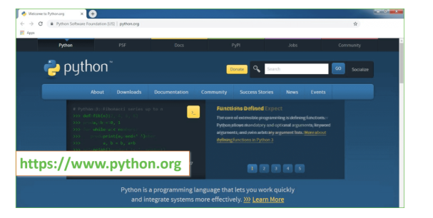

Now, check for the latest and the correct version for your operating system.

**Step 2:** Click on the Download Tab.

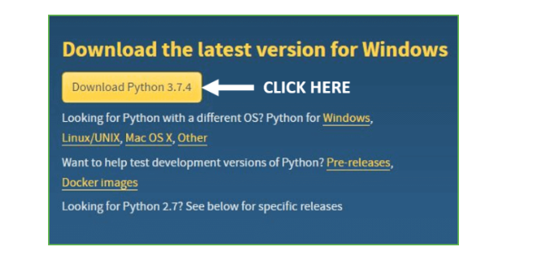

**Step 3:** You can either select the Download Python for windows 3.7.4 button in Yellow Color or you can scroll further down and click on download with respective to their version. Here, we are downloading the most recent python version for windows 3.7.4

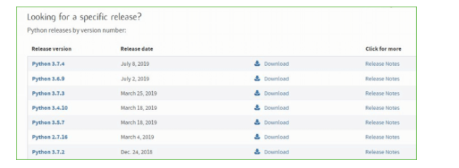

**Step 4:** Scroll down the page until you find the Files option.

**Step 5:** Here you see a different version of python along with the operating system.

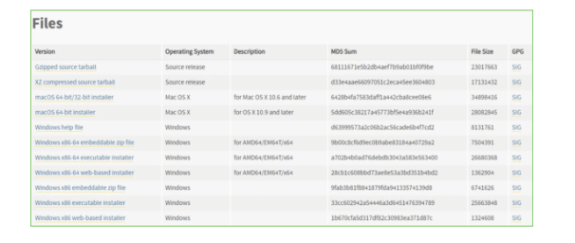

• To download Windows 32-bit python, you can select any one from the three options: Windows x86 embeddable zip file, Windows x86 executable installer or Windows x86 web-based installer.

•To download Windows 64-bit python, you can select any one from the three options: Windows x86-64 embeddable zip file, Windows x86-64 executable installer or Windows x86-64 web-based installer.

Here we will install Windows x86-64 web-based installer. Here your first part regarding which version of python is to be downloaded is completed. Now we move ahead with the second part in installing python i.e. Installation

**Note:** To know the changes or updates that are made in the version you can click on the Release Note Option.

### Installation of Python

**Step 1:** Go to Download and Open the downloaded python version to carry out the installation process.

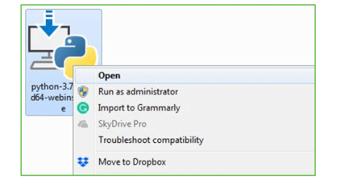

**Step 2:** Before you click on Install Now, make sure to put a tick on Add Python 3.7 to PATH.

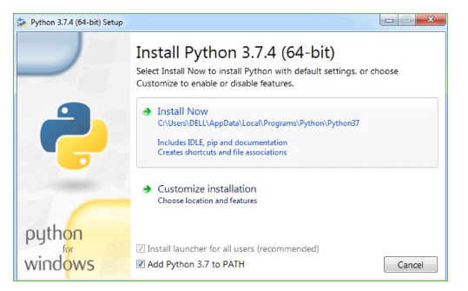

**Step 3:** Click on Install NOW After the installation is successful. Click on Close.

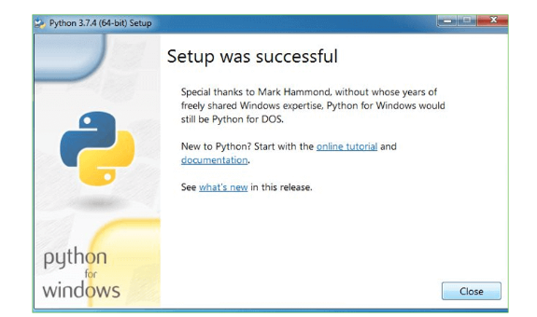

With these above three steps on python installation, you have successfully and correctly installed Python. Now is the time to verify the installation.

**Note:** The installation process might take a couple of minutes.

### Verify the Python Installation

**Step 1:** Click on Start

**Step 2:** In the Windows Run Command, type “cod”.

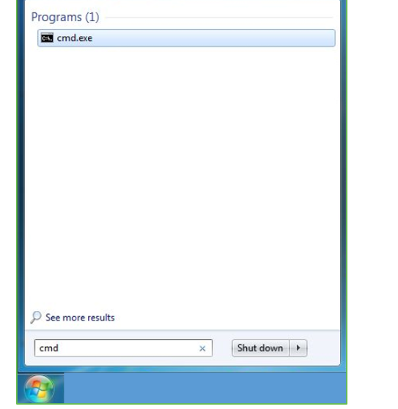

**Step 3:** Open the Command prompt option.

**Step 4:** Let us test whether the python is correctly installed. Type **python –V** and press Enter.

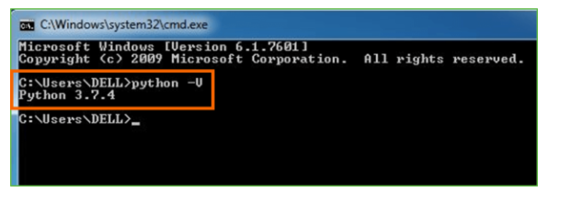

**Step 5:** You will get the answer as 3.7.4

**Note:** If you have any of the earlier versions of Python already installed. You must first uninstall the earlier version and then install the new one.

### Check how the Python IDLE works

**Step 1:** Click on Start

**Step 2:** In the Windows Run command, type “python idle”.

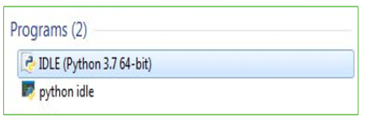

**Step 3:** Click on IDLE (Python 3.7 64-bit) and launch the program

**Step 4:** To go ahead with working in IDLE you must first save the file. **Click on File > Click on Save**

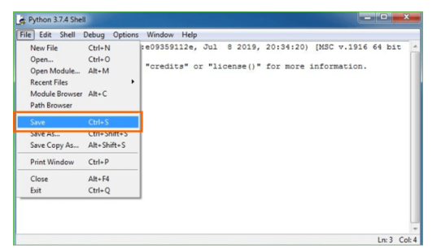

**Step 5:** Name the file and save as type should be Python files. Click on SAVE. Here I have named the files as Hey World.

**Step 6:** Now for e.g. **enter print**

**SYSTEM TEST**

The purpose of testing is to discover errors. Testing is the process of trying to discover every conceivable fault or weakness in a work product. It provides a way to check the functionality of components, sub-assemblies, assemblies and/or a finished product It is the process of exercising software with the intent of ensuring that the Software system meets its requirements and user expectations and does not fail in an unacceptable manner. There are various types of tests. Each test type addresses a specific testing requirement.

### TYPES OF TESTS

**Unit testing**

Unit testing involves the design of test cases that validate that the internal program logic is functioning properly, and that program inputs produce valid outputs. All decision branches and internal code flow should be validated. It is the testing of individual software units of the application .it is done after the completion of an individual unit before integration. This is a structural testing, that relies on knowledge of its construction and is invasive. Unit tests perform basic tests at component level and test a specific business process, application, and/or system configuration. Unit tests ensure that each unique path of a business process performs accurately to the documented specifications and contains clearly defined inputs and expected results.

**Integration testing**

Integration tests are designed to test integrated software components to determine if they actually run as one program. Testing is event driven and is more concerned with the basic outcome of screens or fields. Integration tests demonstrate that although the components were individually satisfaction, as shown by successfully unit testing, the combination of components is correct and consistent. Integration testing is specifically aimed at exposing the problems that arise from the combination of components.

**Functional test**

Functional tests provide systematic demonstrations that functions tested are available as specified by the business and technical requirements, system documentation, and user manuals.

Functional testing is cantered on the following items:

Valid Input: identified classes of valid input must be accepted.

Invalid Input: identified classes of invalid input must be rejected.

Functions: identified functions must be exercised.

Output : identified classes of application outputs must be exercised.

Systems/Procedures: interfacing systems or procedures must be invoked.

Organization and preparation of functional tests is focused on requirements, key functions, or special test cases. In addition, systematic coverage pertaining to identify Business process flows; data fields, predefined processes, and successive processes must be considered for testing. Before functional testing is complete, additional tests are identified and the effective value of current tests is determined.

**System Test**

System testing ensures that the entire integrated software system meets requirements. It tests a configuration to ensure known and predictable results. An example of system testing is the configuration-oriented system integration test. System testing is based on process descriptions and flows, emphasizing pre-driven process links and integration points.

**White Box Testing**

White Box Testing is a testing in which in which the software tester has knowledge of the inner workings, structure and language of the software, or at least its purpose. It is purpose. It is used to test areas that cannot be reached from a black box level.

**Black Box Testing**

Black Box Testing is testing the software without any knowledge of the inner workings, structure or language of the module being tested. Black box tests, as most other kinds of tests, must be written from a definitive source document, such as specification or requirements document, such as specification or requirements document. It is a testing in which the software under test is treated, as a black box. you cannot “see” into it. The test provides inputs and responds to outputs without considering how the software works.

# **Unit Testing**

Unit testing is usually conducted as part of a combined code and unit test phase of the software lifecycle, although it is not uncommon for coding and unit testing to be conducted as two distinct phases.

**Test strategy and approach**

Field testing will be performed manually and functional tests will be written in detail.

**Test objectives**

* All field entries must work properly.
* Pages must be activated from the identified link.
* The entry screen, messages and responses must not be delayed.

**Features to be tested**

* Verify that the entries are of the correct format
* No duplicate entries should be allowed
* All links should take the user to the correct page.

# **Integration Testing**

Software integration testing is the incremental integration testing of two or more integrated software components on a single platform to produce failures caused by interface defects.

The task of the integration test is to check that components or software applications, e.g. components in a software system or – one step up – software applications at the company level – interact without error.

**Test Results:** All the test cases mentioned above passed successfully. No defects encountered.

**Acceptance Testing**

User Acceptance Testing is a critical phase of any project and requires significant participation by the end user. It also ensures that the system meets the functional requirements.

**Test Results:** All the test cases mentioned above passed successfully. No defects encountered.

# Input and Output Screens

Successful software development fully dependent on Design Patterns as this reduce development work by reusing already developed software’s functions. Incorrect design patterns often lead to failure and inexperience often fall prey for incorrect design pattern selection.

To overcome from these issues, we are employing Machine Learning and WEB modules functions which will read source code as input from the user through web interface and then ML algorithms will rank source code to find suitable design pattern and then display predicted design pattern as output.

This ML models can be applied on UI/NON-UI based design patterns selection and for accurate selection we have evaluated performance of multiple ML algorithms like SVM, Random Forest and Decision Tree and each algorithm performance is evaluated in terms of accuracy, precision, recall and FCSORE.

To train above algorithms we have utilized Design Patterns prediction dataset downloaded from GITHUB URL and in below screen showing dataset details

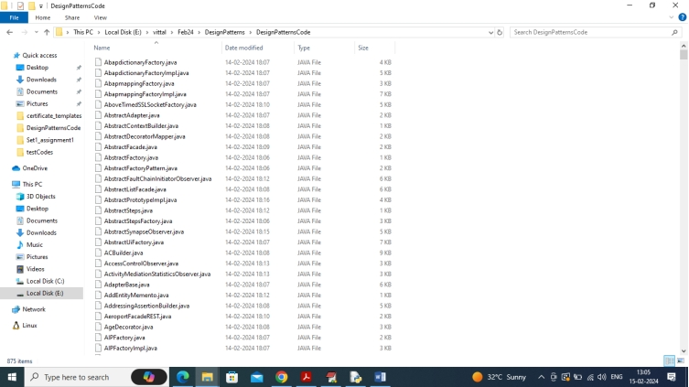

In above screen we have java code from 13 different designs patterns and all those patterns’ names we can see in below file

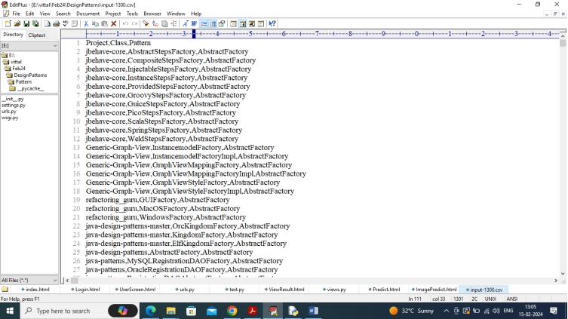

In above file first row represents column names like Project Name, source code class name and the pattern that class is following and remaining rows contains dataset values.

So, by using above java source code we will train algorithms to predict design patterns. Each pattern will be selected by employing ontology based ranking calculations which will calculate rank between dataset source code and user uploaded source code and based in highest ranking Design Pattern will be selected.

By using this project developers can upload existing or current source code files and then application will predict Design Patterns and by using this prediction Developer can what type of code follow what patterns so for his next project he will choose correct patterns.

We have implemented this project as REST based web services which consists of following modules

1. User Login: user can login to system using username and password as ‘admin and admin’.
2. Load Design Patterns Code: after login user will run this module to upload dataset to application
3. Code to Numeric Vector: all codes will be converted to numeric vector which will replace each word occurrence with its average frequency.
4. Train ML Algorithms: processed numeric vector will be split into train and test with a ratio of 80:20. 80% dataset will be input to training algorithms to train a model and this model will be applied on 20% test data to calculate accuracy
5. Predict Design Patterns: user will upload test source code files and then ML algorithms will rank test file to predict accurate design patterns.

SCREEN SHOTS

To run code, install python 3.7 and then install all packages given in requirements.txt file. Now double click on ‘run.bat’ file to start WEB REST server and get below output

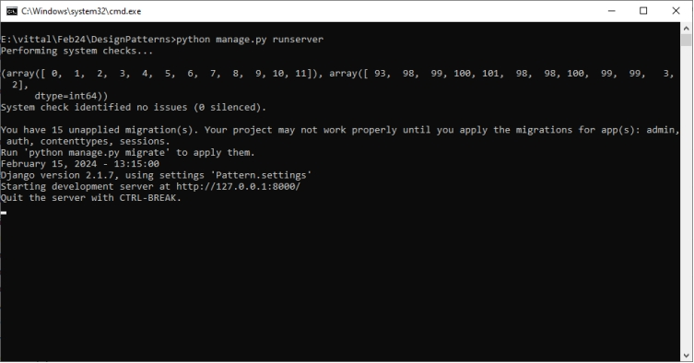

In above screen python server started and now open browser and enter URL as <http://127.0.0.1:8000/index.html> and press enter key to get below page

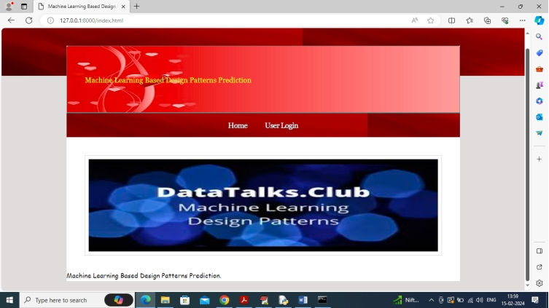

In above screen click on ‘User Login’ link to get below login page

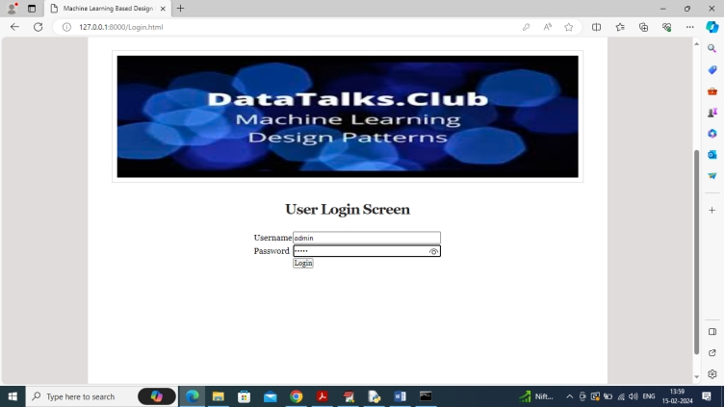

In above screen user is login by using username and password as ‘admin and admin’ and then click on ‘Login’ button to get below page

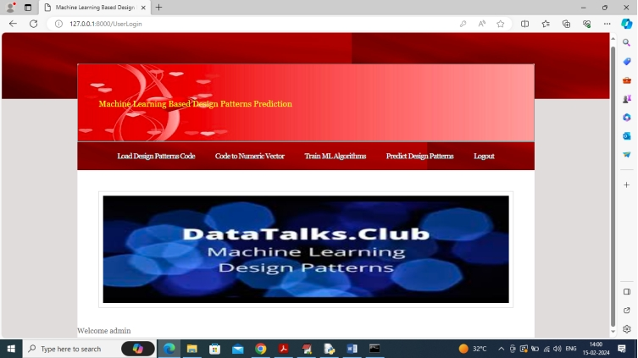

In above screen click on ‘Load Design Pattern Code’ link to load dataset and get below output

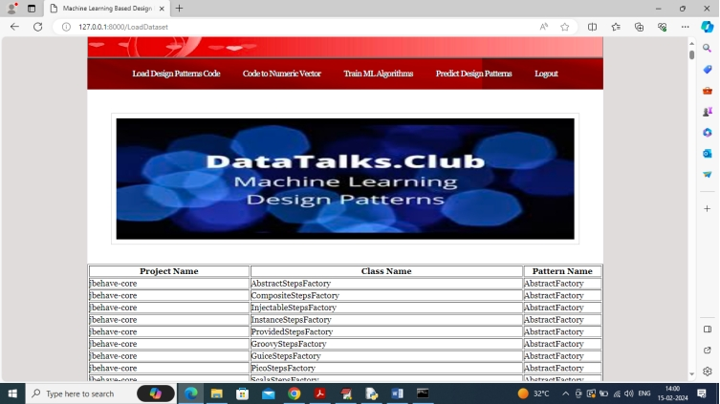

In above screen dataset loaded and now click on ‘Code to Numeric Vector’ link to convert dataset into numeric vector and get below output

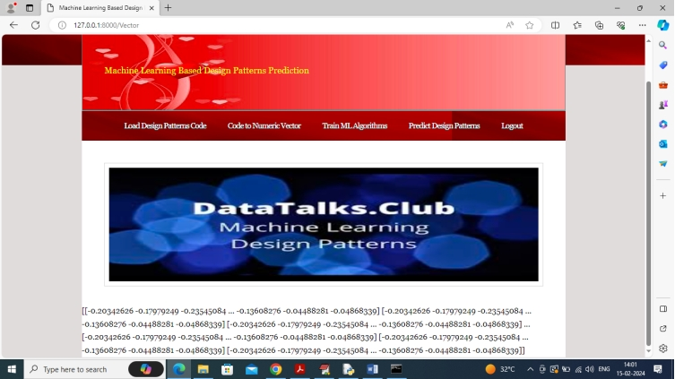

In above screen entire dataset converted to numeric vector and then click on ‘Train ML Algorithms’ link to train ML and get below output

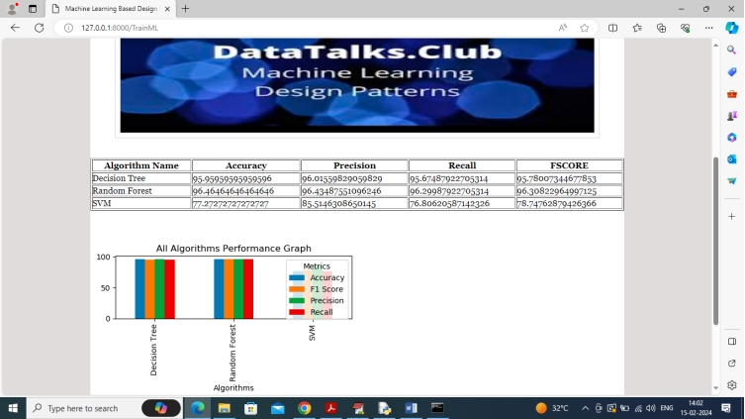

In above screen can see each algorithm performance in tabular and graph format and in all algorithms Random Forest got high accuracy and in graph x-axis represents algorithm names and y-axis represents accuracy and other metrics in different colour bars and now click on ‘Predict Design Patterns’ link to get below page

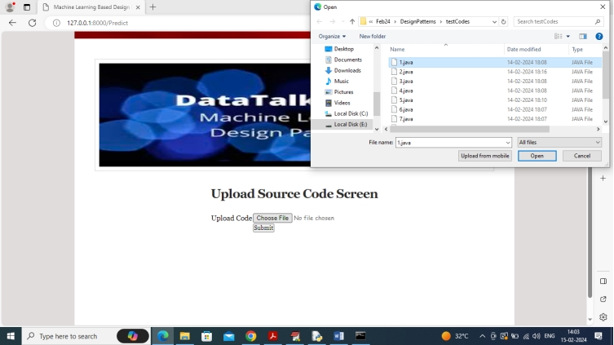

In above screen select and uploading any java source code in UI/non-UI format and then click on ‘Submit’ button to predict names of design pattern

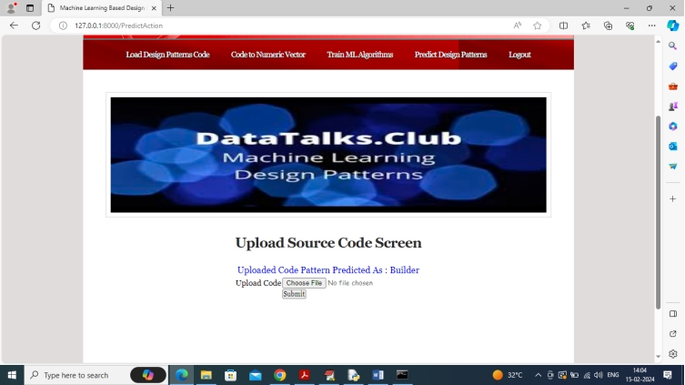

In above screen in blue colour text can see Design pattern predicted from uploaded source code as ‘Builder’ and similarly you can upload and test any other source code. Below is another example

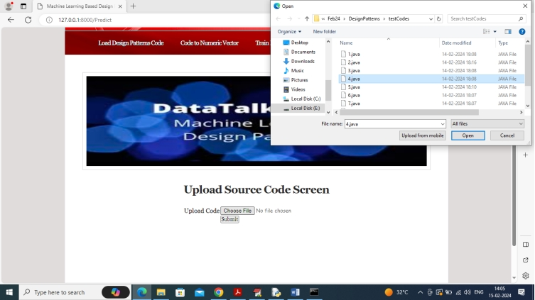

Uploading another code and below is the output

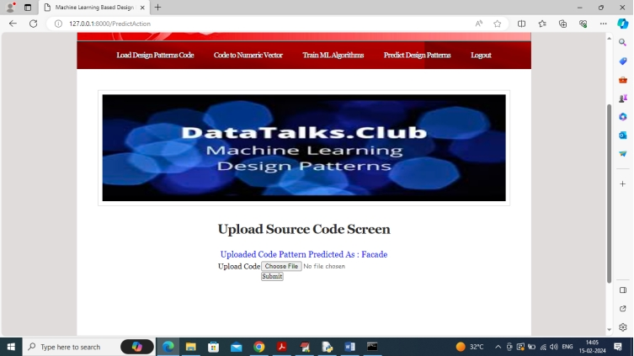

In above screen pattern detected as “Façade”

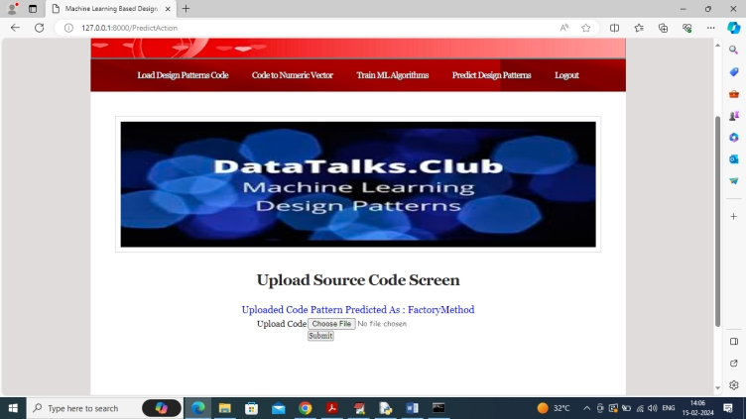

In above screen another code patterns predicted as ‘Factory Method’.

# **Conclusion**

In this study, we explored the development of a machine learning-based system for design pattern prediction, focusing on automating and enhancing the accuracy of design pattern recommendations in software development. Design patterns play a crucial role in building scalable and maintainable software systems, but manual selection often leads to inefficiencies and human error.

By leveraging machine learning techniques, we were able to automate the process of identifying both structural and behavioural design patterns. The system efficiently collects data, extracts meaningful features, trains predictive models, and provides real-time pattern recommendations. This approach significantly reduces the dependency on developer expertise and improves code quality by ensuring the correct patterns are applied in the right context.

Key contributions of the system include:

1. **Automated Pattern Prediction**: Using advanced machine learning algorithms, the system predicts design patterns based on software features, reducing manual intervention.
2. **Behavioural and Structural Pattern Identification**: Unlike traditional rule-based systems, our approach identifies both structural and behavioural patterns, increasing accuracy in dynamic software architectures.
3. **Scalability and Usability**: The system is designed to integrate seamlessly into IDEs, providing real-time feedback and scaling to handle large and complex codebases.

Overall, this system offers a more accurate, efficient, and scalable solution for design pattern prediction, ultimately improving the software design process.

# **Future Scope**

The proposed system, while promising, opens up several avenues for future research and development. Below are key areas that can be explored to extend the capabilities and impact of this work:

1. **Enhancing Model Accuracy and Adaptability**:
   * **Deep Learning Approaches**: Future work can involve the application of more sophisticated deep learning techniques like Graph Neural Networks (GNNs) and Recurrent Neural Networks (RNNs) to capture even more complex relationships between code components, leading to improved prediction accuracy.
   * **Self-Learning Systems**: Implementing reinforcement learning or active learning mechanisms where the system improves based on user feedback and interactions over time.
2. **Incorporating Contextual and Domain-Specific Patterns**:
   * The current system works well with general design patterns, but future versions could be tailored to identify **domain-specific design patterns**, such as those used in specialized fields like artificial intelligence, embedded systems, or web development.
   * **Context-Aware Predictions**: Future models can be trained to consider the specific context of the project (e.g., software type, performance requirements) to make more tailored recommendations.
3. **Expanding Dataset and Continuous Learning**:
   * Expanding the dataset by incorporating a broader range of open-source projects or proprietary software can improve the model’s ability to generalize. The system can be designed to continuously learn from new projects and patterns, keeping it up-to-date with emerging design trends.
   * **Automated Data Labelling**: Developing techniques to automate the annotation and labelling of design patterns in software repositories will reduce manual labour in expanding training datasets.
4. **Integration with More Development Tools**:
   * While current integration is focused on popular IDEs like IntelliJ IDEA, Eclipse, and Visual Studio, expanding support to other development environments (e.g., cloud-based IDEs, mobile development platforms) would make the system more accessible.
   * **Collaborative Platforms**: Integration with collaborative development platforms like GitHub or GitLab could allow teams to receive real-time design pattern recommendations during code reviews or pull requests.
5. **Real-Time Pattern Detection in Code Repositories**:
   * Future iterations of the system could actively monitor ongoing software development projects in real-time, scanning for potential design pattern usage or anti-patterns in continuous integration pipelines.
   * **Code Quality Feedback**: Expanding the system to detect violations of design principles or identify areas where patterns can improve software quality will enhance its utility in both legacy codebases and new projects.
6. **Explainability and Developer Insights**:
   * Incorporating explainable AI techniques to provide **insights** into why specific design patterns are recommended will enhance trust in the system. Developers can benefit from understanding the rationale behind predictions, leading to better learning outcomes.
   * **Pattern Visualization**: Providing graphical representations of design patterns within the codebase can help developers better visualize and understand pattern application and structure.
7. **Supporting Code Refactoring**:
   * An extension of the system could provide **automated refactoring suggestions**, ensuring that developers not only identify potential design patterns but also receive guidance or automated scripts to refactor the code accordingly.
8. **Security Patterns Prediction**:
   * Future work could focus on extending the system to detect **security-related design patterns** (e.g., patterns for secure software design) and help developers implement secure code by recommending patterns that mitigate specific security risks.

**References**

1. Gamma, E., Helm, R., Johnson, R., & Vlassises, J. (1994). *Design Patterns: Elements of Reusable Object-Oriented Software*. Addison-Wesley Professional.
2. Buschmann, F., Meunier, R., Rohnert, H., Sommerlad, P., & Stal, M. (1996). *Pattern-Oriented Software Architecture, Volume 1: A System of Patterns*. Wiley.
3. Antoniol, G., Fiutem, R., & Cristoforetti, L. (1998). Design pattern recovery in object-oriented software. *Proceedings of the 6th International Workshop on Program Comprehension (IWPC)*, 153-160.
4. Dong, J., Yang, Y., & Zhang, K. (2009). Design pattern detection by template matching. *Proceedings of the 2009 ACM symposium on Applied Computing*, 765-769.
5. Hammad, M., Alnusair, A., & Zhao, L. (2013). Using machine learning techniques for design patterns recognition. *Journal of Software Engineering and Applications*, 6(6), 313-320.
6. Zhang, J., Zhang, H., & Gu, X. (2006). A rule-based automatic approach to detecting design patterns. *Proceedings of the 2006 Asia-Pacific Software Engineering Conference (APSEC)*, 489-496.
7. Tsantalis, N., Chatzigeorgiou, A., Stephanie’s, G., & Halides, S. T. (2006). Design pattern detection using similarity scoring. *IEEE Transactions on Software Engineering*, 32(11), 896-909.
8. Malhotra, R., Bansal, A., & Bajaj, K. (2017). A machine learning approach for detecting design patterns. *Journal of King Saud University-Computer and Information Sciences*, 29(2), 182-193.
9. Chen, Q., Zhang, L., & Sun, C. (2019). Detecting design patterns with deep learning. *Proceedings of the 41st International Conference on Software Engineering (ICSE)*, 999-1010.
10. Kim, M., Cai, Y., & Schurles, W. (2020). Hybrid approach to design pattern detection using rule-based and machine learning techniques. *Journal of Systems and Software*, 162, 110510.